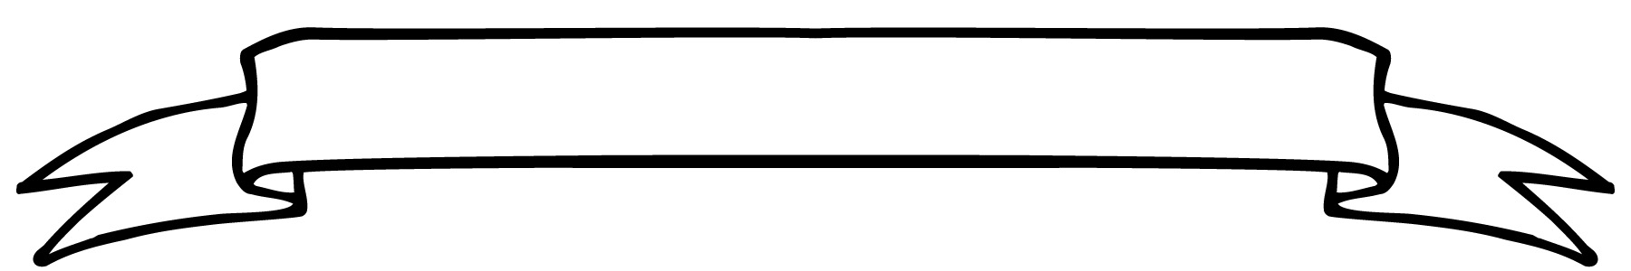
Willow Class Newsletter

This week the children have enjoyed learning about Florence Nightingale in English. They have designed machines to help the Faithful Friends and they have written notes about their machines.
In maths we have started looking at adding a one-digit number to a two-digit number and we will build on this next week and move on to adding a multiple of 10 to a 2 digit number.
We are still learning new massage techniques, and the children are enjoying working with Cally.
They have loved the PE sessions with Steve on a Wednesday and have been working on ball skills.
In Mike’s Meadow we looked at bridge building which linked with the topic we have done this term involving looking at the work of Isambard Kingdom Brunel.
Next week the children will be looking at the life of Mary Seacole. We are going to be comparing her life to Florence Nightingale.
We are looking forward to Multiskills at Bathampton on Friday. Please let me know if you are able to walk with us.
Looking forward to another fun week.
Alison, Beth and Natalie

09.10.2026


Teacher’s Awards
This week Bea and Ted
were awarded the Teacher’s Award this week for consistently being kind and inclusive.

Homework
Reading - we will send home a decodable book on Monday and Thursday. Please read these with your child focussing on their use of sounding words they do not know. Remember to record in the reading record book when you read with your child.
Please let me know if you would like to come in and read with children as any adult support is welcomed.
Please remind your child to put their book bag into the box rather than leaving them in their bags as then they will have their book changed.

Dates:-
Monday – Massage in Schools Project/Mike’s Meadow playtime and History (Wellies will be useful)
Tuesday – PE
Wednesday - PE
Thursday pm- Natalie PPA cover.
Friday – Multiskills Festival

