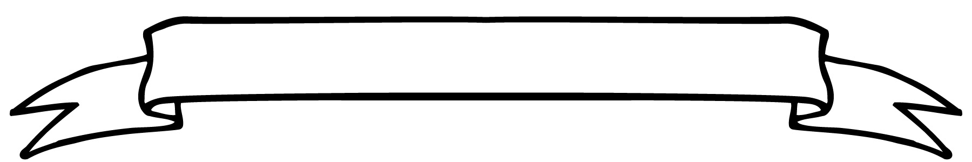
Willow Class Newsletter

Wow
What a week that was. What began as a late in the term Monday ended with the Ofsted call!
Willow Class really rose to the occasion and did us proud. They showed their resilience and enthusiasm in a Curious Quest session and their number skills in maths. I was so proud of them all as in the second heatwave of the term the end of year relaxation was suddenly changed!
This coming last week together should be far more chilled!
During our Curious Quest session the children were sent a book about Ancient Egypt and although this is not a history topic in KS1 their enthusiasm has led to us creating some amazing factsheets and this week I have planned some more Egyptian activities.
On Thursday Olivia and I have decided to take KS1 on a Topic Day to the Bathampton Meadows and Secret Garden. Willow Class will be comparing our own River Avon to the River Nile in Egypt. We will be using some of the geography skills we have learnt this term to look at natural and human made features and to think about the uses and wildlife around the river area (as well as some free play in the Secret Garden). Please could all children bring a packed lunch that day so we can maximise the time spent. They can also come in their home clothes rather than school uniform. Look out for a more detailed letter coming from Olivia.
Although this is a great way to end the year, I am feeling sad that this year is nearly over as Willow Class have been such a lovely class to teach with their endless enthusiasm and sense of fun!
Best wishes
Alison, Lucy, Hannah, Sarah, Natalie, Mel, Tim

12.07.2026


Natalia and Clemmie
earnt the Teacher’s Awards this week for their constant enthusiasm and kindness.

Nyx was awarded the Handwriting Award for the term.

Homework
Reading – This term we will continue to send home a reading book every Monday and Thursday. Please read these with your child focussing on their use of sounding words they do not know. Remember to record in the reading record book when you read with your child. During our assessment week we will also begin to assess children ready to use AR reader in KS2
Spelling: As well as Spelling Fish we have also been working on what happens to a word when we add a suffix – taking off an e (Make -making), Changing a y to an I (happy – happiness) and doubling letters (hop – hopping) Any practise of this at home would be great to imbed this knowledge.
Times Tables – Times Table Rockstars is great to practise skills.. Practise of counting in 2s, 5s and 10s will also support the children.
We have a community reader joining us each Wednesday who will be reading with some of the children.

Dates:-
Monday – Mike’s Meadow making Egyptian Shaduf
Wednesday pm- Natalie PPA cover.
Wednesday and Friday – PE Kits.
Thursday – Nature/Geography Day (please bring packed lunch)

