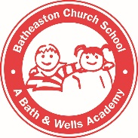
All About Me
Things that help me
I feel happy when…
I might need help with…
Things that comfort me if I am upset…

Things I like
My favourite toys/games
My favourite books/stories
My favourite interests
My favourite food
My Family
People I live with:
Brothers / Sisters (names/ages):
Special relationships (grandparents/other adults):
Pets:
Name:
Preferred name/nickname:
Date of birth:
Home language:

Any other useful information:

Development and Personality
I am good at…

Friendships
Friends I already know at school:
Friends I know from my nursery:
Starting School
How do I feel about starting school?

What might I be worried about?

