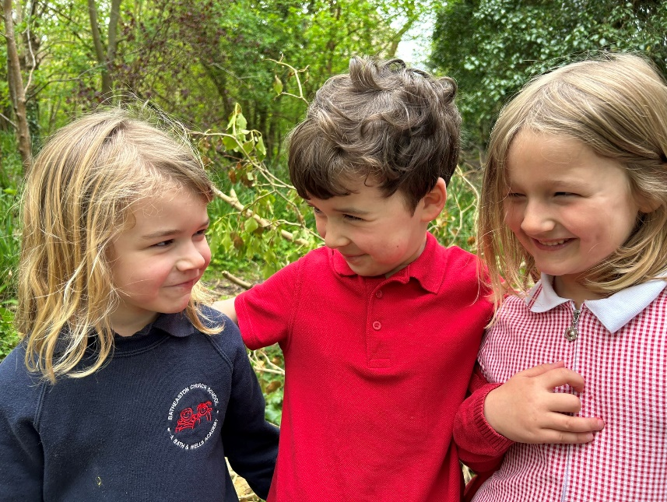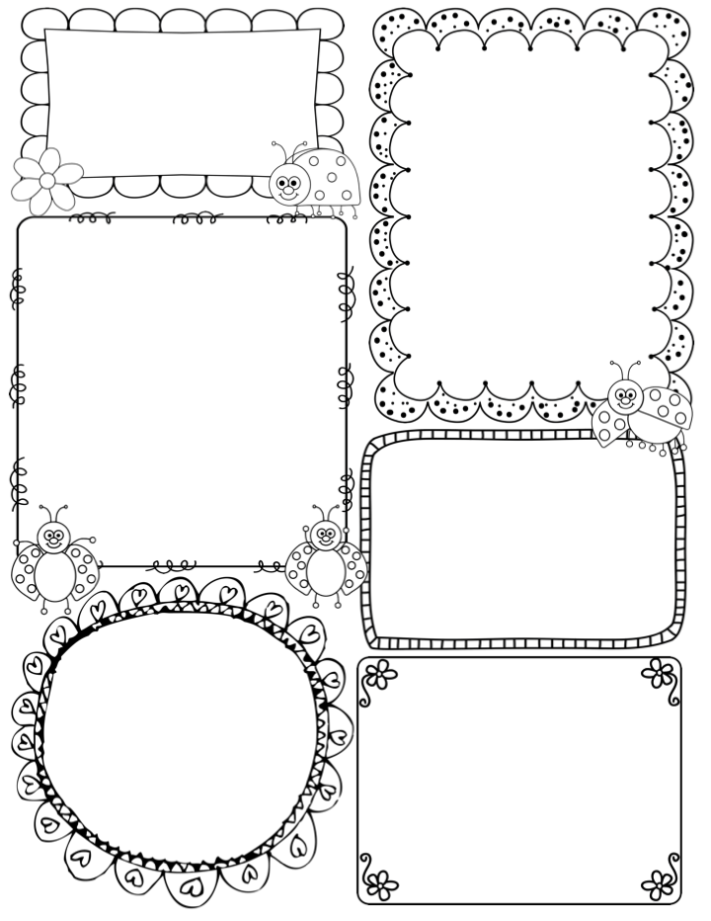

News / Information

**Welcome back, we hope you enjoyed your Easter break – I am sure the children have all come back looking a little taller!!**

**Our new topic this term is ‘Tell me a story…’ We will be using story books for inspiration to re-tell or make up our own stories. The children will use a variety of formats to tell a story such as writing, small world play, construction, outside, role-play, puppets and story mapping. Traditional tales will be the main theme of many activities – starting with Goldilocks and the Three Bears this week. Please take a look at the knowledge organiser for more details.**

**Tilly will be coming back to us for just one week, this week. She has been an amazing asset to the team through her kind, mature and enthusiastic manner towards the children.**

**We will be attending Celebration Assemblies on Friday mornings from now on. You may get a phone call from Gail inviting you in, if your child is to receive a award. The assemblies start at 10am and you are welcome to stay on after for Funky Friday playtimes.**

***Finally, if you are interested in helping in class, please come in and see me for details.***

**Teacher Awards**

Phonics

**Phase 4** –Last week we begin Phase 4 of the Little Wandle phonics scheme. The children will continue to revisit Phase 3 phonemes and tricky words. They were introduced to CVCC words (consonant, vowel, consonant, consonant) such as best, hump and help. Tricky words: so, said, have, like / some, come, do, love / CCVC words: frog, smell, swim

This week…

In drawing club we are using the story of the Goldilocks and the Three Bears. I know this will be a popular choice and we have lots of fun activities planned around this book. Drawing Club continues to be a favourite activity within the class, but now we are able to plan more writing opportunities as the children’s confidence and motivation to write develops.

In maths we are revisiting the concept of subitising with quantities up to 6. The children already are able to recognise random and familiar patterns with numbers 3, 4 and 5 so this will be an extra challenge.

We will continue our mini Design and Technology challenge this week. Last week we began the project with popular traditional tale ‘The Three Little Pigs and the Big Bad Wolf’ The children were asked to think about what makes a home a home. This week they will look at designing a new home for the pigs and considering the best materials to build a stable building. We will also look at the alternative story ‘The Three Little Wolves and the Big Bad Pig’. In PE we are concentrating on honing our games skills using a variety of equipment plus working in small teams in preparation for Sports Day, next term.

**Apple Class Newsletter**

**Summer 1 22nd April 2024**