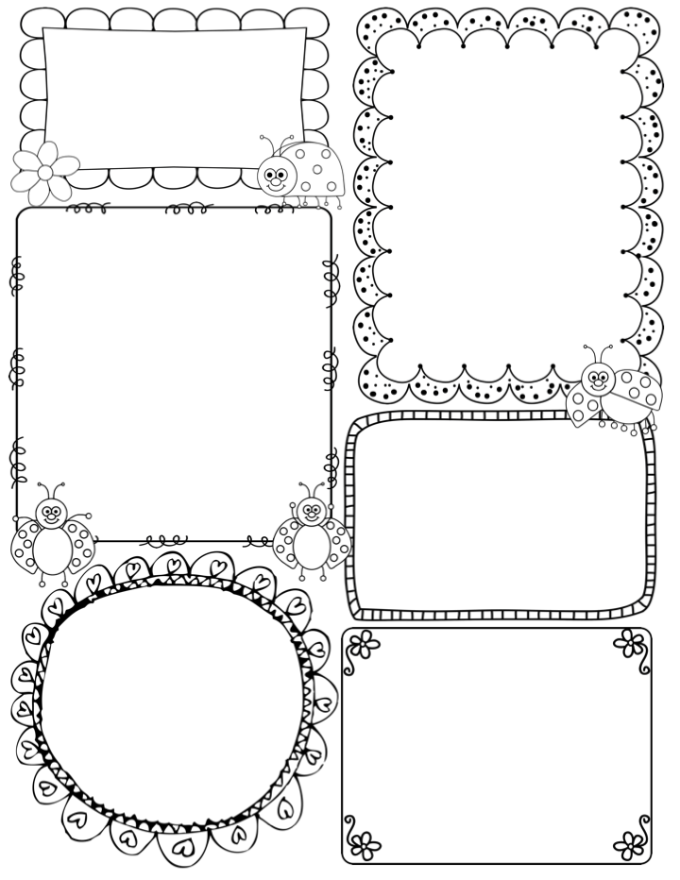

News / Information

**Firstly, thank you so much to all the parents who came, after school, to weed and tidy up the Apple Class garden. It looks absolutely amazing. I felt quite emotional at the end of the day, as it is such a big job for me to do on my own! Also thank you for the donations and offers of plants for the pots. The summer term is going to be in bloom for the children.**

**We had such a lovely day in Mike’s Meadow, with our special friends. The weather was with us and the children were really inspired by the art and craft activities Joe and I set up.**

**With this in mind, we will set another date in the summer term to meet up with our special friends in the meadow. I am also now planning a school trip, so will keep you posted.**

**Things to remember this week:**

**Monday is Science day; Apple Class will be joining the rest of the school in mixed age groupings.**

**Easter Bonnets and Easter Lunch on Wednesday 27th. Plus, a special Easter celebration in the Church on Thursday at 10am – parents are welcome.**

**PE kits may be taken home after Tuesday’s lesson with Jon.**

**Teacher Awards**

**Henry and Rosa P**

**Apple Class Newsletter**

**Spring 2 25th March 2024**

This week…

On Monday Apple Class will be joining the whole school for Science Day. The children will be placed into mixed aged groups, alongside their special friends. Over the day the groups will visit different teachers to take part in a science lesson. This will be an exciting opportunity to learn about different science concepts, in a fun and engaging way.

On Tuesday, Jon will introduce Drawing club, this week it is Animation week – a classic Bugs Bunny cartoon. It is based upon the fable ‘The Hare and the Tortoise’ of course the Cecil the Turtle will win the race much to Bugs Bunny’s annoyance!!

This week we will conclude our art and craft learning with more printing and Easter themed activities that the children will love!

At the end of the week, the children will have a surprise (shhhhh!) Easter Egg hunt in Mike’s Meadow, with hot cross buns as a treat.

Have a wonderful Easter break, enjoy the rest and Georgie and I will see you next term. Thank you for your ongoing support and enthusiasm. Nikki

Phonics

**Phase 3** –This week I will be assessing each child again in readiness for next term when we begin Phase 4 of the Little Wandle programme. Again I will send home a short report for each child.