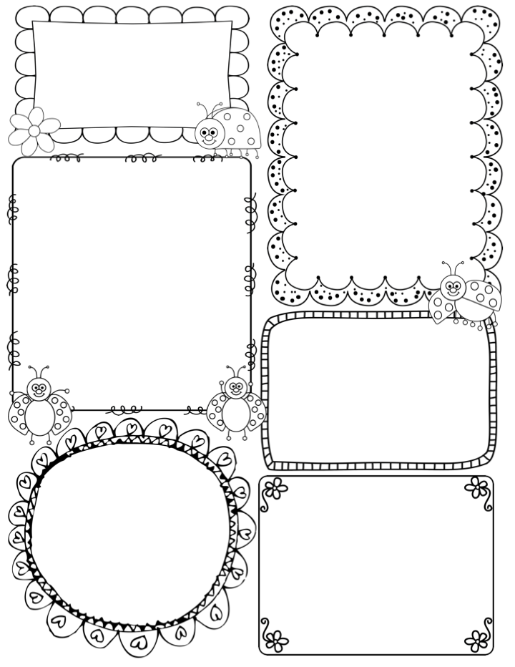

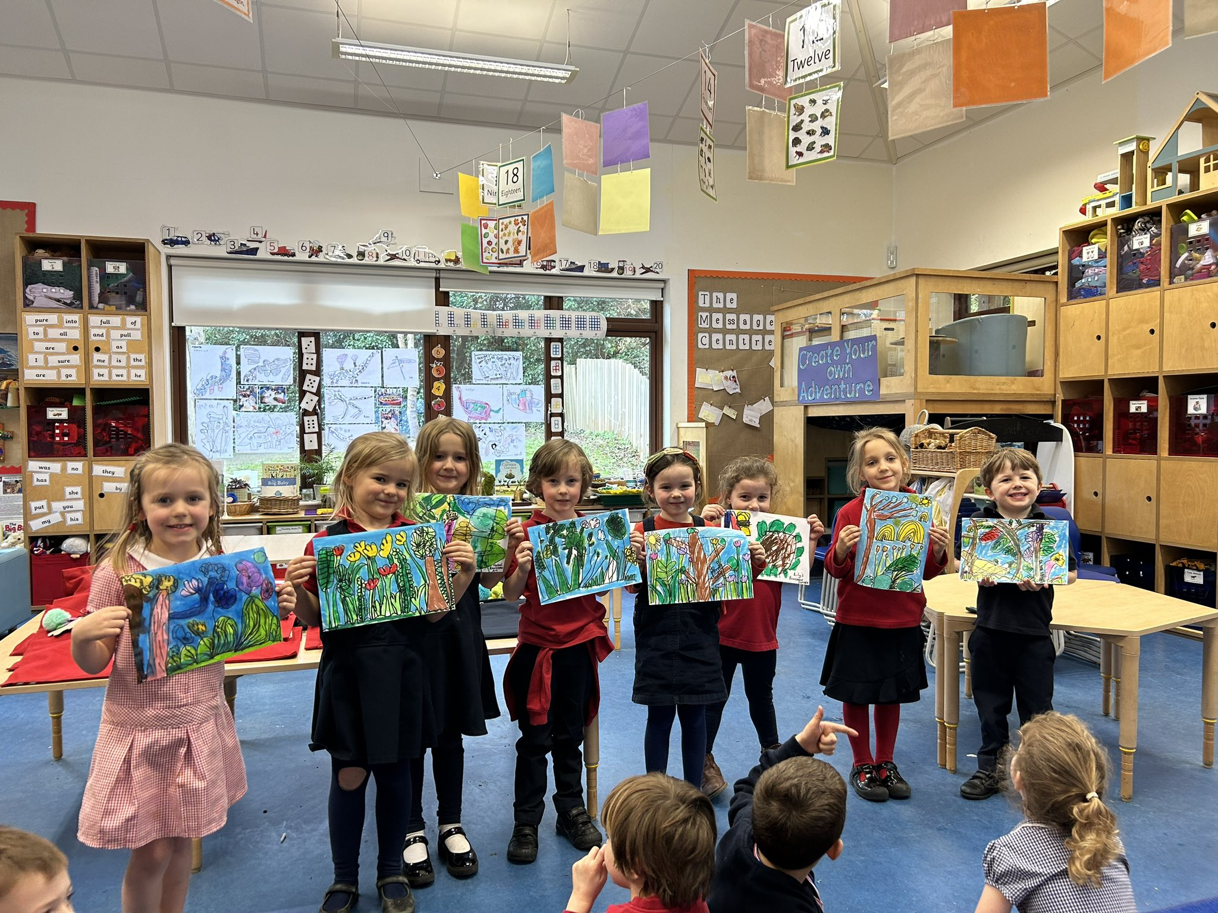

News / Information

**We had such a lovely time last week, the children were so inspired by the book ‘Bog Baby’ drawing club was as busy as ever! We also looked at the artist Henri Rousseau and we were so impressed with the children’s artworks and attention to detail when drawing by observation. Please do come into the classroom and take a look at all the wonderful art that has taken place this term.**

**I am sending home a letter with details about our day in Mike’s Meadow on Friday. Please ensure you read it so that you are aware of what we intend to do.**

**Don’t forget to sign up for parents meetings, the list is outside the classroom door. The first meeting is on Thursday 21st and the second is on Tuesday 26th. I am really looking forward to sharing with you your child’s progress and successes.**

**You may have noticed that we have a Norland Nanny student. Tilly will be with us all week (except Fridays) until the end of this term. She is really lovely and has lots of experience of working with young children.**

**Teacher Awards**

**Henry and Mabel**

**Apple Class Newsletter**

**Spring 2 18th March 2024**

This week…

In Drawing Club it is a Traditional Tale, ‘The Little Red Hen’. It will be a familiar story to the children and I know it will inspire them in their drawings and writing. The children will also be asked to create a story map, showing the characters and the journey the Hen takes to eventually making his bread.

In maths we are revisiting ‘sorting and classifying’, asking the children to look for ways to sort a group of objects. We are challenging the children to look beyond colour or type and instead looking at the properties of an object such as a shape.

In art we are going to follow the technique of printing from last week, this time mono-printing. The children will experiment with lines and shapes to create a simple image that will be printed onto paper.

In science we are looking at the different parts of a flowering plant and learning about the purpose of each part such as *the roots which holds the plant in place and sucks up water and nutrients from the soil.*

Phonics

**Phase 3** –This term we will be revisiting all Phase 3 phonemes, tricky words and decodable words – including double letters. Keep an eye out for the home learning sheet on the back of this newsletter, this will help support your child at home.