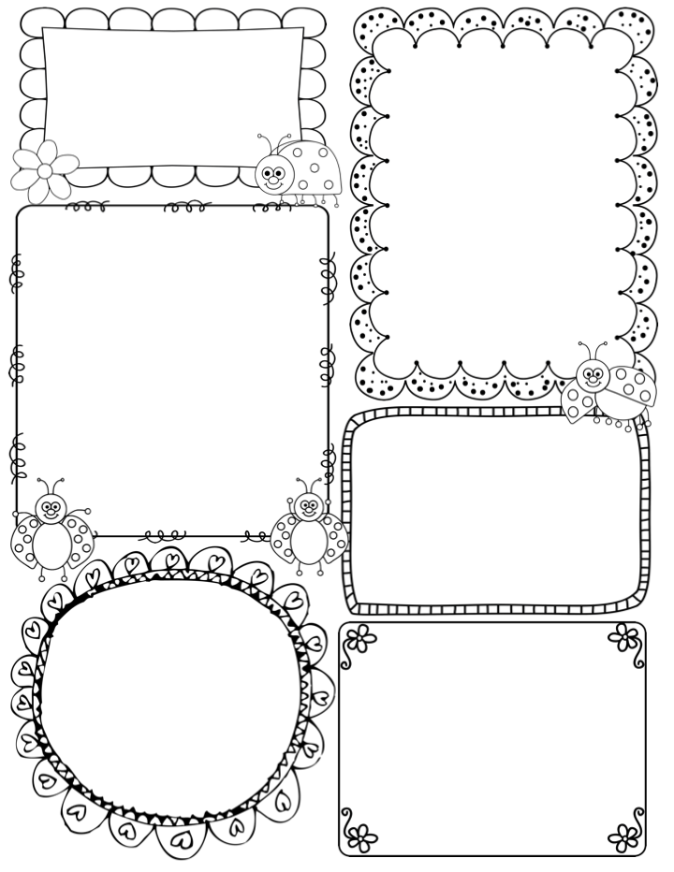

**Apple Class Newsletter**

**Spring 2 26th February 2024**

News / Information

What a lovely first week we had together, if only the weather was less rainy!! However, in our classroom, there is a definite springtime feel.

Last week we spent some time learning our Spring Concert songs, I know that the children have been happily singing along at home. **Our concert is today, starting at 3.30pm. The doors to the hall will be open from 3.15 for you all to take your seat.**

**On Wednesday morning, Harriet (Lorna’s Mum) will be taking the class, as I will be attending the first ‘Tea and Talk’ meeting for parents. This is open to parents to come along and be a part of shaping key issues raised from the questionnaire.**

On Tuesday we have a Head teacher and EYFS teacher visiting us in Apple Class, from a school within the Trust. They are keen to see Drawing club in action and take a look at our environment and teaching and learning.

**PE – will be on Tuesdays and Thursdays – Please ensure your child’s kit is in school (all clothes named).**

**Teacher Awards**

**Lyra and Bodhi**

This week…

In drawing club we are using a familiar ‘Traditional Tale’, Jack and the Beanstalk. This story will lead nicely into our science work based upon growing plants from seeds. We know this will be popular, so I am looking forward to the drawings that will be created. We are starting with the Giant for our character, so watch out!

In maths we are focusing on the number 8 and looking at comparisons in quantities up to 10. The children will use their skills of subitising to find out if a quantity has more or fewer. In PE Jon and I will be focusing on games skills; sending and receiving, aiming, throwing, catching and having an awareness of space and others.

On Topic Friday we will learn about what a plant needs to grow successfully. We use ‘Jasper’s Beanstalk’ as a stimulus for planting our own beans and seeds.

In art we will revisit observational drawing, this time using spring flowers to view and draw. Over the weeks the children will have access to range of media to paint and draw.

Phonics

**Phase 3** –This term we will be revisiting all Phase 3 phonemes, tricky words and decodable words – including double letters. Keep an eye out for the home learning sheet on the back of this newsletter, this will help support your child at home.