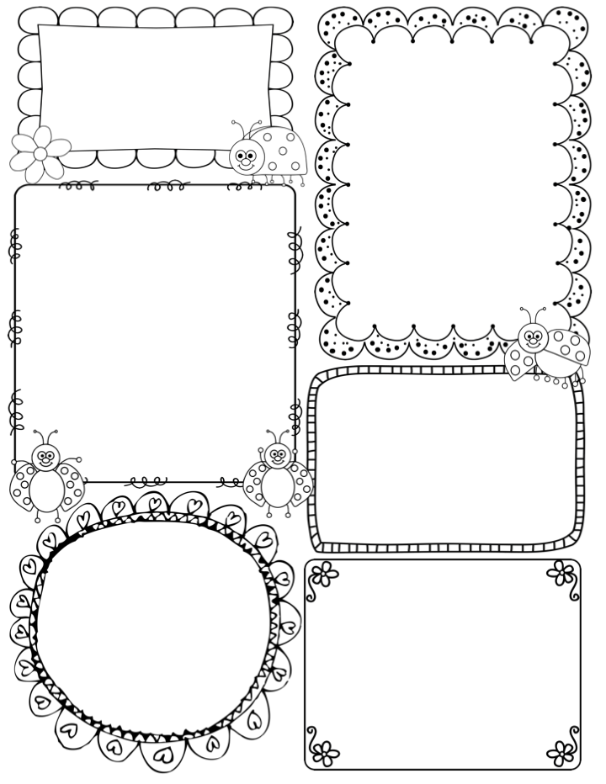****

News / Information

Millie was very sad to leave on Friday, and the children were also sad to see her go. She is determined to come back and visit – having been there myself (a long time ago!!) you never forget your first class.

This week is very exciting as it is ‘Story Telling Week’. The children will use their amazing spoons to make up their own stories alongside their friends. We have a visiting author and illustrator on Tuesday – Robert will visit each class and work with the children. I am really looking forward to showing off the children’s drawing skills. On Wednesday it is ‘Bedtime Story’ evening, from 5.30pm til 6.30pm. I will be there, in my PJ’s, with a certain doggy friend!!

We are nearing the end of this terms Phase 3 phonics, therefore, I will begin to hear each child individually read, and alongside the termly assessment will be in a good place to see their progress.

Thank you, all those parents who have commented on our display, in the lobby area. I do love displaying the children’s work, and I must say we have also seen the older children commenting and admiring the display x

**Teacher Awards**

**James and Lorna**

This week…

In drawing club I think the class are going to love the book chosen ‘Are the dinosaurs dead, Dad?’ Its all about a Dave and his Dad, who are visiting a museum. Dave is convinced that the dinosaur exhibit are in fact alive and well!! The main source of hilarity will be the most fearsome ‘The T Rex’. I am looking forward to the children’s drawings in response to mine! I am starting to feel a little inadequate, in comparison to the ideas and drawings the children are producing!!

In maths the children are excited to be focusing on 6 and 7. We will continue with the concept of finding and investigating ways in which to represent 6 and 7 and in turn develop their understanding of the different compositions of this number. We had a Joe and the chair of Governor visit the other week and they were highly impressed with the children’s deepening knowledge of number and numerical patterns.

This week we will be to look at music composition with a view to composing a simple piece using sound patterns and percussion instruments.

Phonics

**Phase 3** – This week we will be looking at longer words and using a method called ‘chunking’ to break down a word such as ‘pic-nic’ we will also look at compound words such as ‘laptop/popcorn’ which are two words together to form one.

Review tricky words and digraphs/trigraphs

**Apple Class Newsletter**

**Spring 1 29th January 2024**