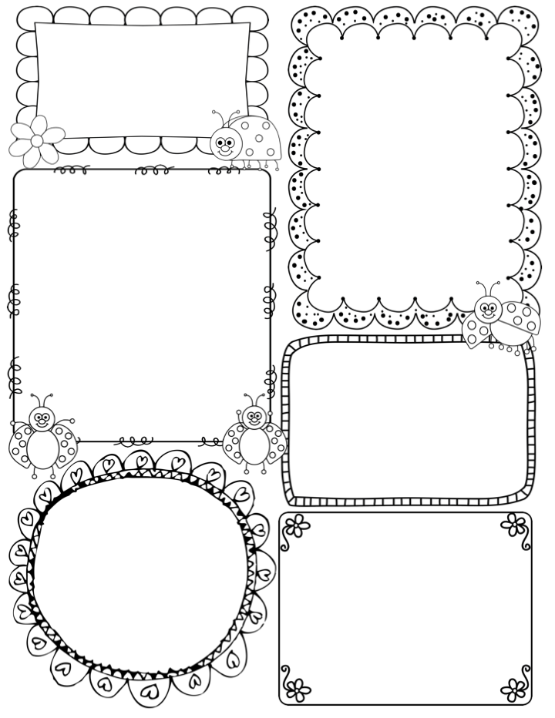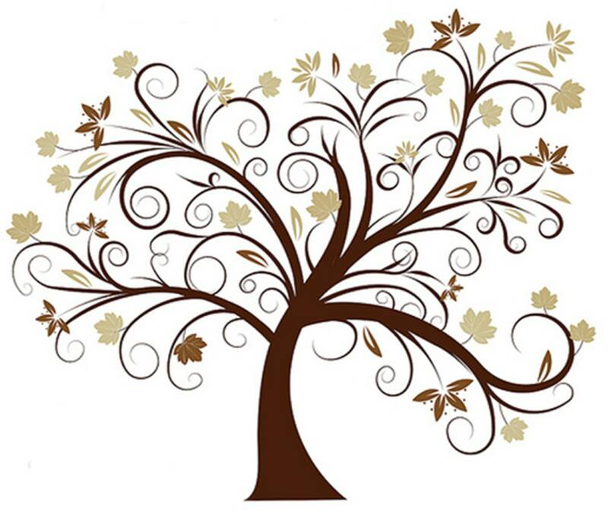

News / Information

It is Millie’s last week with us in Apple Class, she will be finishing on Friday. I know the children really missed her last week, but she was very ill and sad that she couldn’t be in for her penultimate week. Fingers crossed she will be good for Monday, and we are going to make sure she has a lovely send off. I think you will agree with us, that she has been a lovely, calm and caring addition to our team.

We have already heard the children talking about their designs for their wooden spoons. If you missed the email about our Story Telling week, from Monday 29th Jan to Friday 2nd Feb, please take a look at the website for the details. The spoons should be brought back in by Monday 29th.

We were visited by Sarah, a Reception teacher from Bathwick St Mary’s on Wednesday, she wanted to see Drawing Club in action. I received a lovely email from her later, thanking me and Apple class for welcoming her so readily. I was so proud of how friendly and willing the children were, to show off their skills and enthusiasm for drawing and writing. No wonder she was impressed.

**Teacher Awards**

**Lucas and Lola**

This week…

I am really looking forward to sharing our new book in Drawing Club this week. It is The Odd Egg, by Emily Gravett. It follows the tale of Duck, who finds an egg to look after. All the other birds think it is odd, but he thinks it’s the most beautiful egg in the world! Of course, the overriding question is, who is inside the egg!! I think the children will be really inspired by this, and might have a surprise waiting for them during the week- shhh!

In maths we are focusing on Five, honing our skills of finding two parts to 5 such as 3+2 or 4+1. We will used a selection of resources for the children to investigate 5, which I know they enjoy. You could practise this at home too.

Millie is hoping to finish the children’s clay fossils this week, and support the children’s skill of sorting and classifying dinosaurs. Following on from our work last week, where we used non-fiction books to find facts, we are hoping the children will put this factual knowledge to good use.

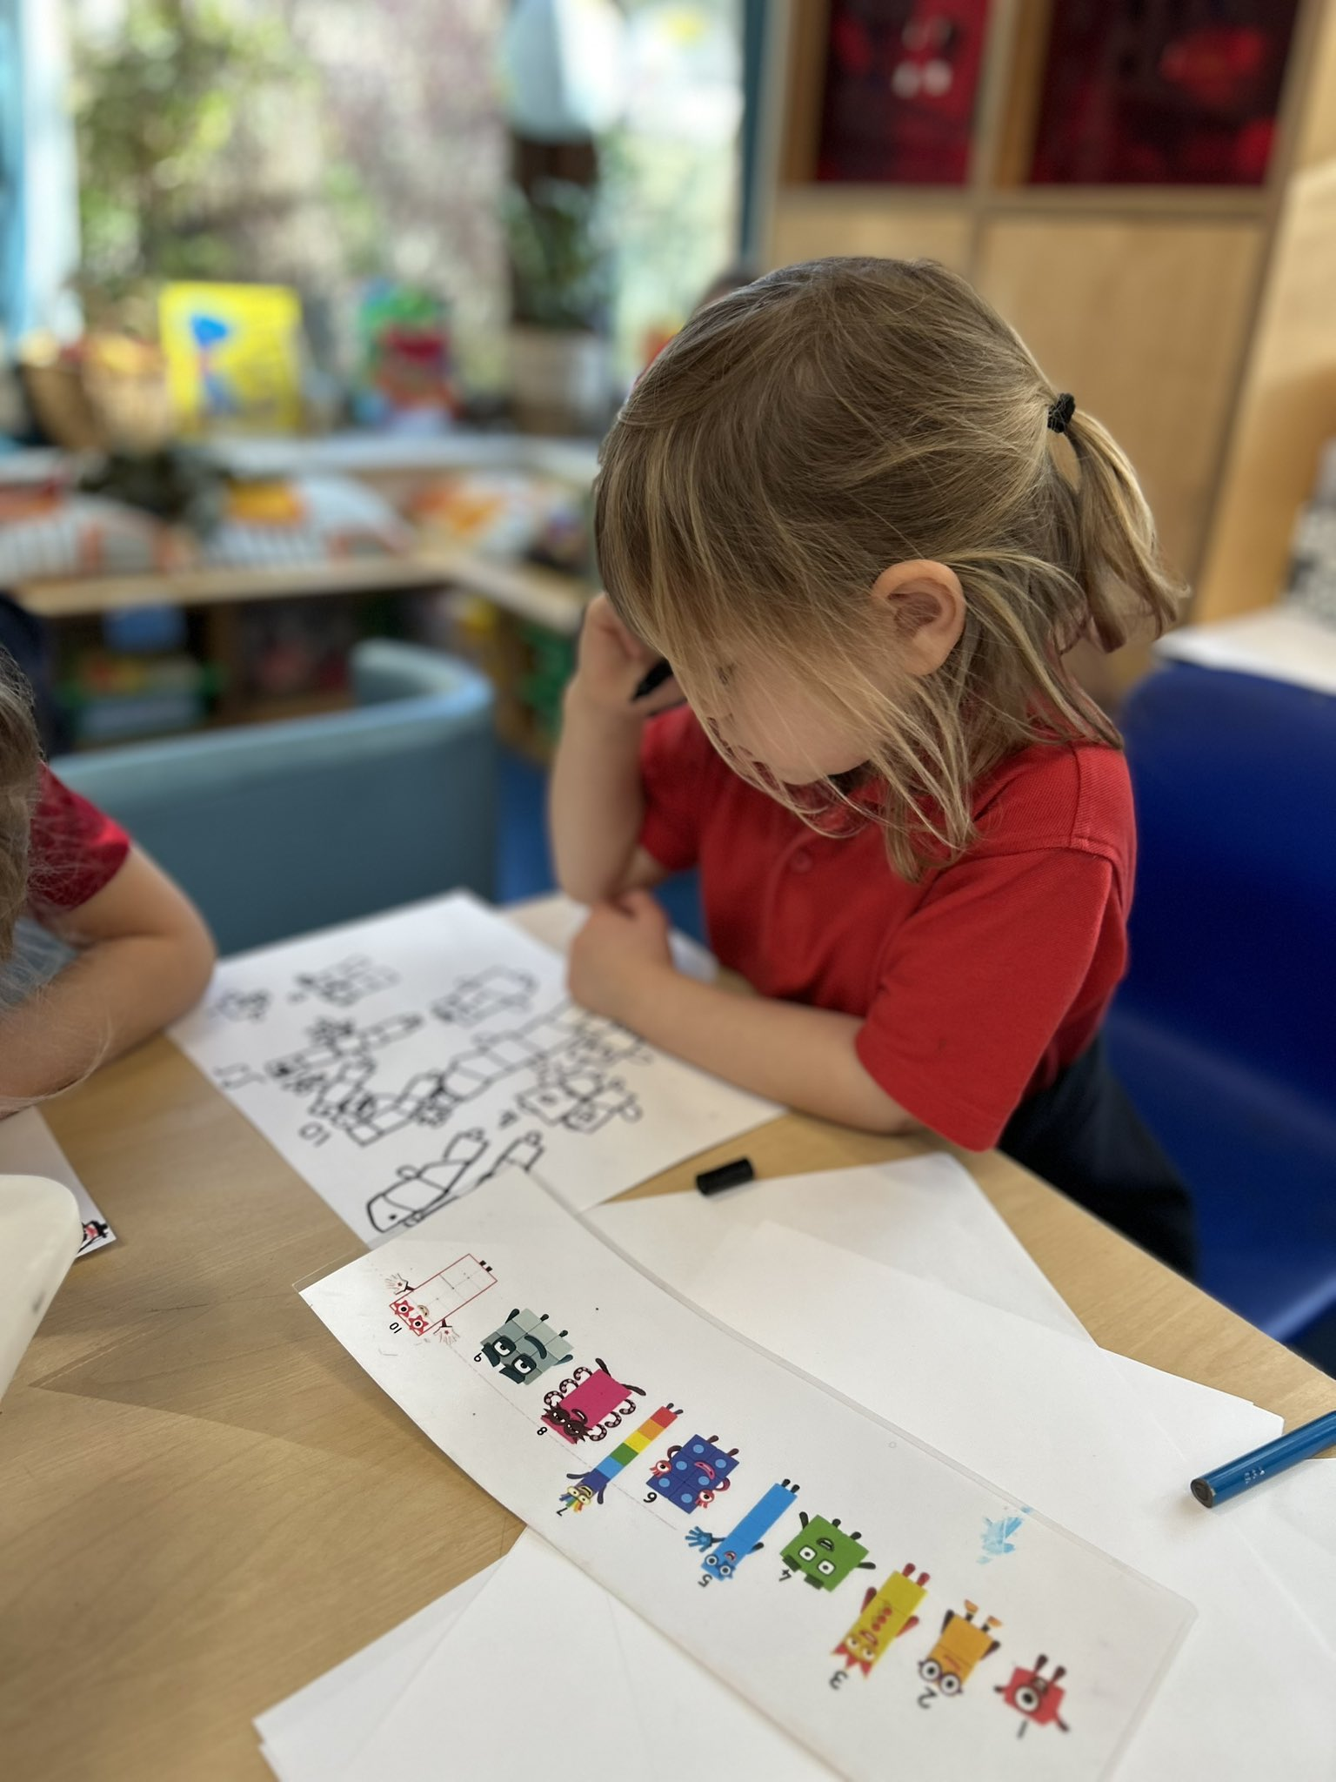

Phonics

**Phase 3** – This will be the final set of digraphs and trigraphs in Phase 3. Next term we will spend time revisiting them. We will also be looking at words with double letters this week – dd, mm, ff, pp, gg, rr, tt, bb

This week: air, er

New tricky words – are, sure, pure

**Apple Class Newsletter**

**Spring 1 22nd January 2024**