****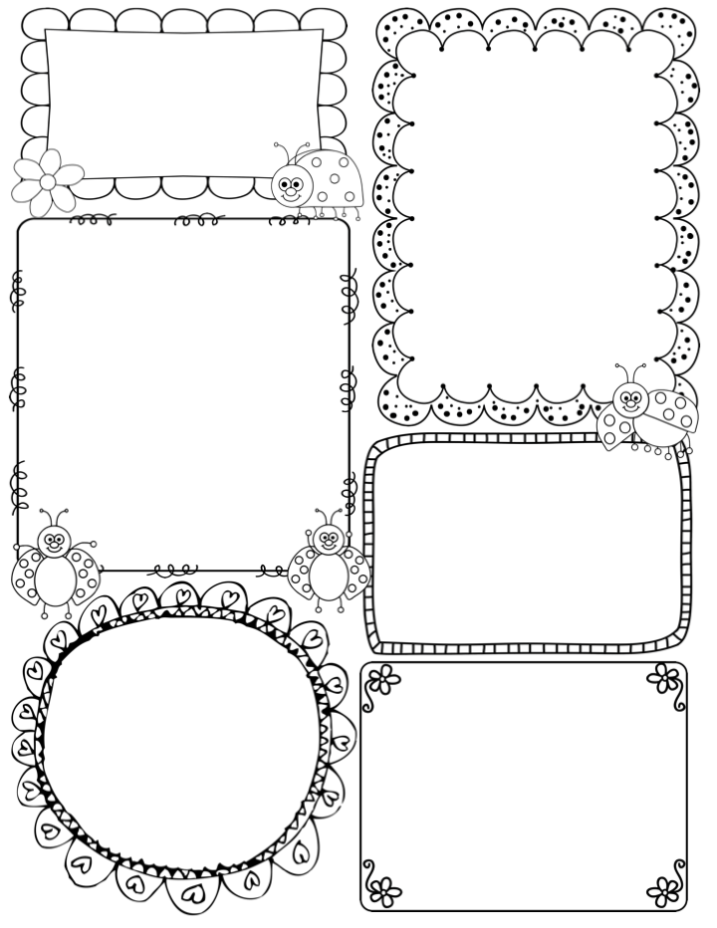

This week…

In drawing club we are using the book ‘Tom and the Island of Dinosaurs’ as our inspiration. The children will be revisiting the concept of journeys and travel, finding ways to help a little girl stranded on a deserted island with dinosaurs. Volcanos will also be explored in this book, followed up later in the term too.

In maths we are looking beyond the number 5, developing their understanding and skill of ‘subitising’ – the ability to recognise and identify the number of objects in a random pattern up to 6. This term the children will be creating such patterns and matching them to the corresponding numbers. Numberblocks will be key this term too – it is a fab program of videos that support the foundations of number with young children.

Following on from last week, where Millie, taught the class about the concept of past (both recent and a long, long time ago) The class will learn about Mary Anning – one of my favourite people to explore. She was a pioneer for fossil hunting in Victorian times, but was not recognised until later, after her death. Her life is fascinating and a real inspiration for future Palaeontologists.

Phonics

**Phase 3** – We will be learning new

digraphs and trigraphs– please use the home learning sheet to support your child with these new sounds.

This week: oa, oo *oo*, ar, or

New tricky words – was you they

**Teacher Awards**

**Sonny and Henry**

News / Information

As to be expected, the children are buzzing with excitement about our new topic ‘Walking with Giants’. Already the class have started by learning about the concept of ‘past’. On Friday they loved looking at my selection of old artefacts and fossils, including my own childhood doll, who is very old!!!

We also got a special delivery from Andy (Andy’s Dinosaur Adventures on Cbeebies). Inside was a letter, his hat and an old camera. He has also loaned us some fossils and a very large bone – already the class have speculated about who it once belonged to – a T Rex seems a popular choice.

Watch the display space in the lobby area, soon there will be some lovely work to go up. Already in Drawing club, the children have enjoyed drawing dinosaurs.

The challenge has been set – the children are now in training to be Palaeontologists, so their journey to be dino experts has begun.

If your child has a book, fossil or interesting object to bring in, please do encourage this. We love it when children take home their learning and wish to share with their friends in class.

**Apple Class Newsletter**

**Spring 1 8th January 2024**

