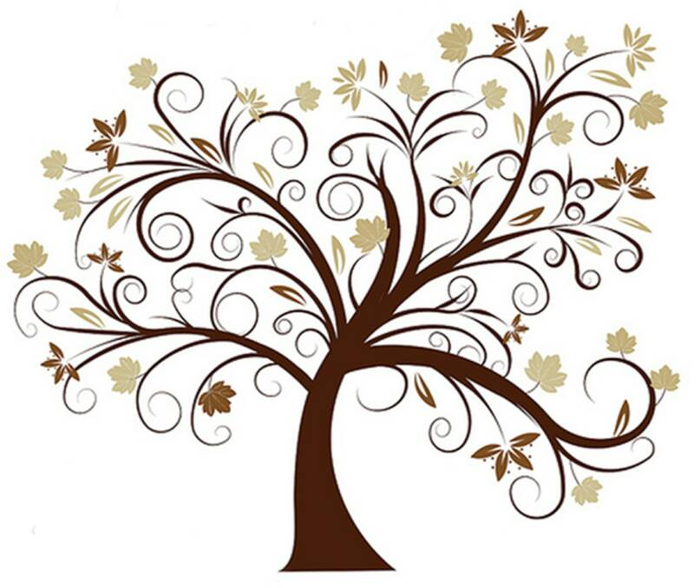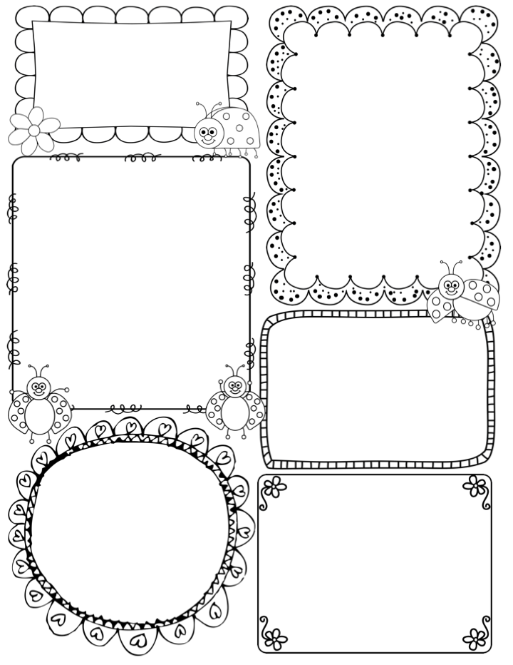

This week…

We will begin the week reading the picture book ‘Dinosaurs Galore’. This is a great introduction to the different dinosaurs that roamed the land over 66 million years ago. The children will be asked to draw their favourite dinosaur and write labels to identify the parts of their body.

The class will begin their Palaeontology training by learning about what a dinosaur is. What are their key attributes. We will explore the different types of dinosaurs and how they lived. The children will also learn about the concept of ‘past’ thinking about their own lives and those who lived a long time ago. As dinosaurs are a pre-historic animal, the children will use non-fiction books, fossils and artefacts to learn more and delve deeper into the world of dinosaurs.

In drawing club, Millie will read ‘The Girl and the Dinosaur’ all about a girl loves to look for dinosaur bones on the beach near where she lives. She dreams of finding a whole skeleton!

In PSHE this term we are looking at the theme of ‘dreams and goals’. Last week we discussed how we can overcome challenge if we persevere. This week we will be looking at personal goals.

Phonics

**Phase 3** – This week we will began Phase 3 of the Little

Wandle phonics scheme. We will be learning new

digraphs and trigraphs– please use the home learning sheet to support your child with these new sounds.

This week: ai, ee igh

Keep practising tricky words – as, is, pull, full, I, the

**Teacher Awards**

News / Information

Welcome back everyone, we hope you had a lovely Christmas break. Firstly, we would like to thank you for your very generous gifts given to us at the end of term. We felt very appreciated, thank you.

This term we are not breaking with tradition it’s all about the dinosaurs! The topic title is ‘Walking with Giants’.

Already the children are excited by this theme. Today we received a special gift from Andy (CBeebies Dinosaur Adventure). He sent an email and left an old suitcase (with his hat!!). Inside the suitcase were fossils and a very large bone!! All borrowed from the Museum. This has peaked the children’s interest somewhat, as you can imagine. This term the children will also be working towards their ‘Palaeontology’ award!

For PE, Jon and Millie will be taking Dance on Tuesday afternoons, and myself Gymnastics on Thursday. I will be getting out the large apparatus, so a polite reminder that all long hair be tied up.

Millie will be taking over for up to 60% of the timetable, with me supporting. She is excited to take on more responsibility for the next 3 weeks.

**Apple Class Newsletter**

**Spring 1 3rd January 2024**

