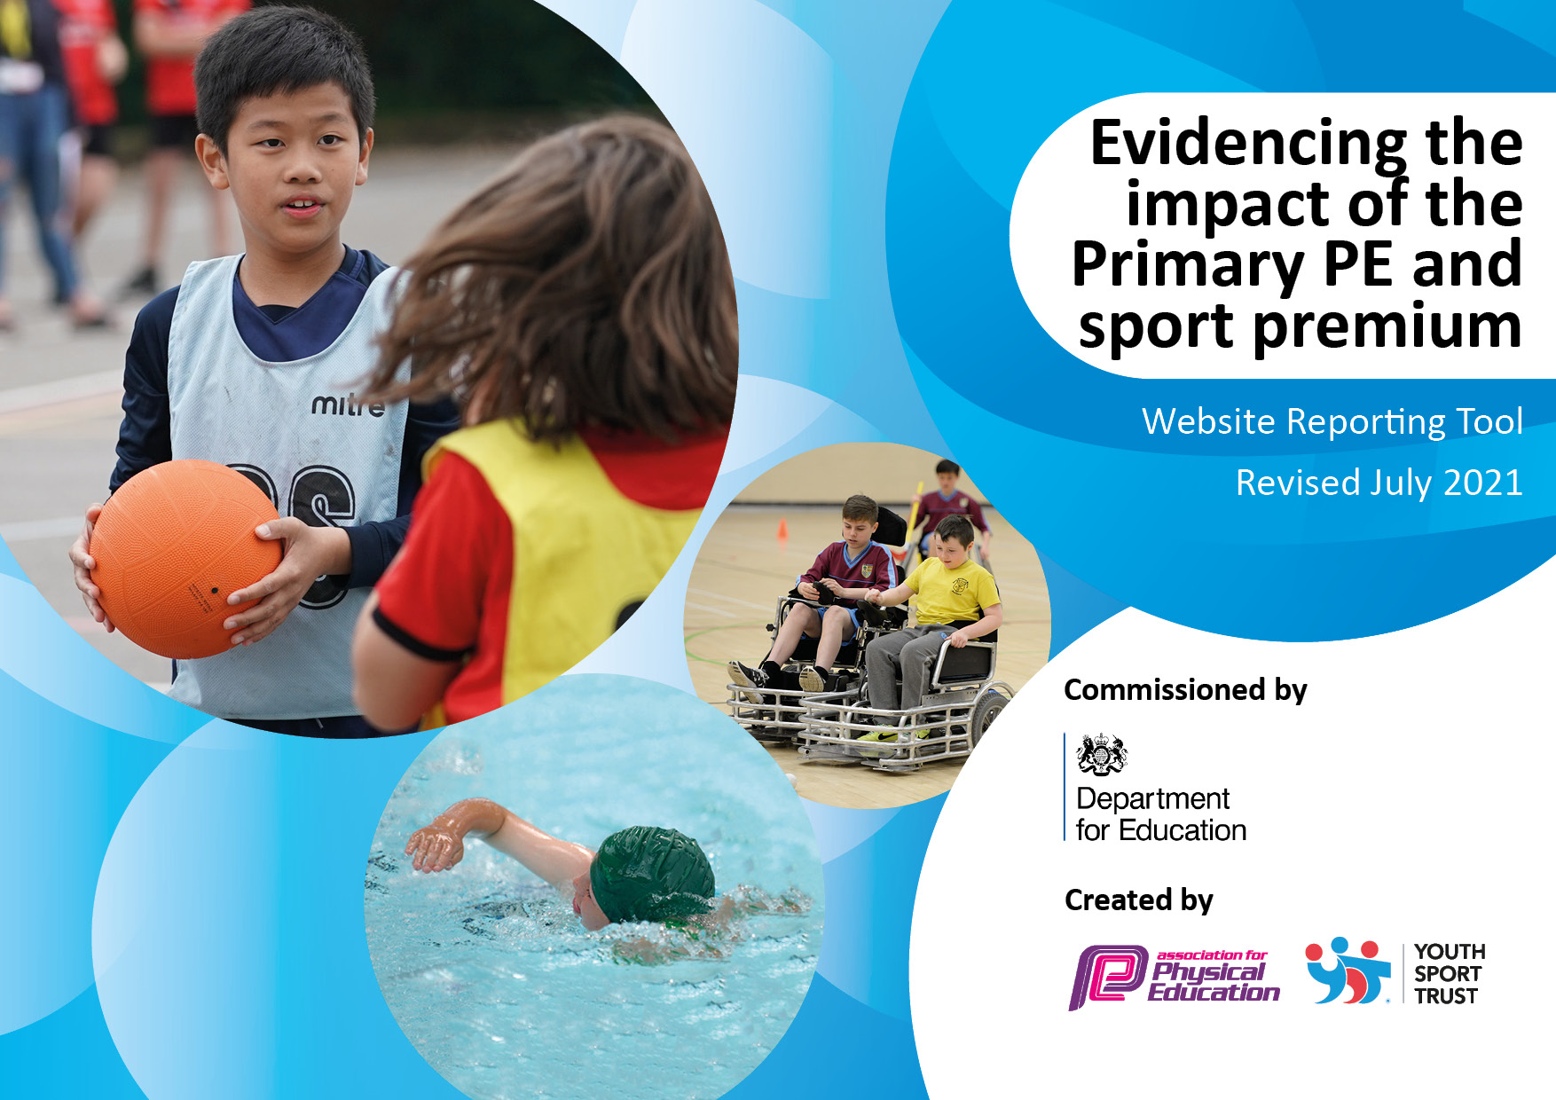
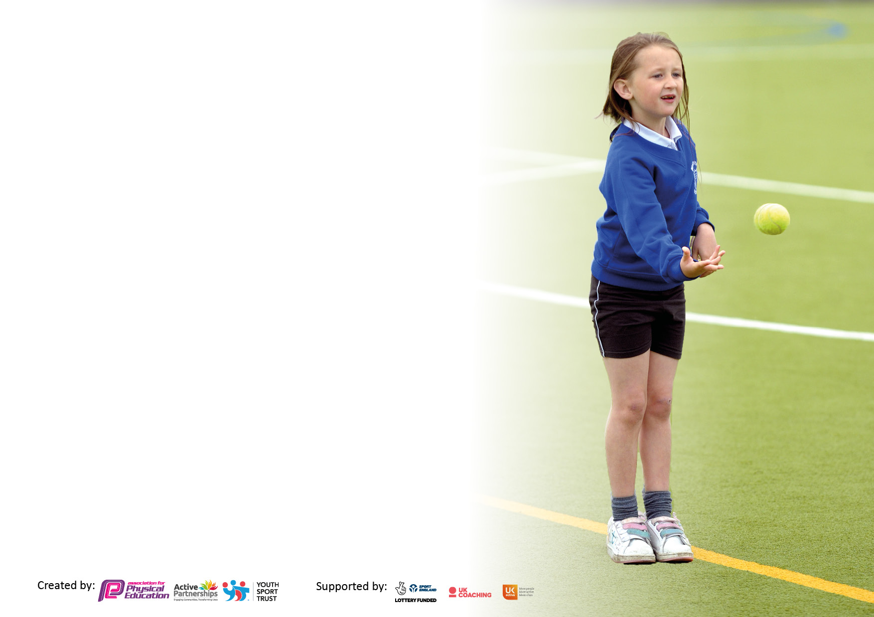

It is important that your grant is used effectively and based on school need. The Education Inspection Framework makes clear there will be a focus on ‘whether leaders and those responsible for governors all understand their respective roles and perform these in a way that enhances the effectiveness of the school’.

Under the Quality of Education Ofsted inspectors consider:
Intent - Curriculum design, coverage and appropriateness
Implementation - Curriculum delivery, Teaching (pedagogy) and Assessment
Impact - Attainment and progress

To assist schools with common transferable language this template has been developed to utilise the same three headings which should make your plans easily transferable between working documents.

Schools must use the funding to make additional and sustainable improvements to the quality of Physical Education, School Sport and Physical Activity (PESSPA) they offer. This means that you should use the Primary PE and sport premium to:

- Develop or add to the PESSPA activities that your school already offer
- Build capacity and capability within the school to ensure that improvements made now will benefit pupils joining the school in future years
- The Primary PE and sport premium should not be used to fund capital spend projects; the school’s budget should fund these.

Pleasevisitgov.ukfortherevisedDfEguidanceincludingthe5keyindicatorsacrosswhichschoolsshoulddemonstrate animprovement.Thisdocumentwillhelpyoutoreviewyourprovisionandtoreportyourspend.DfEencouragesschools to use this template as an effective way of meeting the reporting requirements of the Primary PE and sport premium.

We recommend you start by reflecting on the impact of current provision and reviewing the previous spend.

Schools are required to publish details of how they spend this funding, including any under-spend from 2019/2020, as well as on the impact it has on pupils’ PE and sport participation and attainment. All funding must be spent by 31st July 2022.

We recommend regularly updating the table and publishing it on your website throughout the year. This evidences your ongoing self-evaluation of how you are using the funding to secure maximum, sustainable impact. Final copy must be posted on your website by the end of the academic year and no later than the 31st July 2021. To see an example of how to complete the table please click HERE.
Created by: Supported by:

Details with regard to funding
Please complete the table below.

Total amount carried over from 2020/21 | £95
Total amount allocated for 2021/22 | £18, 235
How much (if any) do you intend to carry over from this total fund into 2022/23? | £1,905
Total amount allocated for 2022/23 | £17,690
Total amount of funding for 2022/23. To be spent and reported on by 31st July 2023. | £19,865
Swimming Data
Please report on your Swimming Data below.

Meeting national curriculum requirements for swimming and water safety.

N.B. Complete this section to your best ability. For example you might have practised safe self-rescue techniques on dry land which you can then transfer to the pool when school swimming restarts.
Due to exceptional circumstances priority should be given to ensuring that pupils can perform safe self rescue even if they do not fully meet the first two requirements of the NC programme of study
What percentage of your current Year 6 cohort swim competently, confidently and proficiently over a distance of at least 25 metres?  N.B. Even though your pupils may swim in another year please report on their attainment on leaving primary school at the end of the summer term 2021.  Please see note above | 67%
What percentage of your current Year 6 cohort use a range of strokes effectively [for example, front crawl, backstroke and breaststroke]?  Please see note above | 67%
What percentage of your current Year 6 cohort perform safe self-rescue in different water-based situations? | 64%
Schools can choose to use the Primary PE and sport premium to provide additional provision for swimming but this must be for activity over and above the national curriculum requirements. Have you used it in this way? | Yes/No

Action Plan and Budget Tracking
Capture your intended annual spend against the 5 key indicators. Clarify the success criteria and evidence of impact that you intend to measure to evaluate for pupils today and for the future.

 | Academic Year: 2022/23 |  | Total fund allocated: |  | Date Updated:
 | Key indicator 1: The engagement of all pupils in regular physical activity – Chief Medical Officers guidelines recommend that primary school pupils undertake at least 30 minutes of physical activity a day in school |  |  |  |  |  |  |  | Percentage of total allocation:
 |  |  |  |  |  |  |  |  | 53%
 | Intent |  | Implementation |  |  |  | Impact
 | Your school focus should be clear what you want the pupils to know and be able to do and about  what they need to learn and to  consolidate through practice: |  | Make sure your actions to achieve are linked to your intentions: |  | Funding allocated: |  | Evidence of impact: what do pupils now know and what can they now do? What has changed?: |  | Sustainability and suggested next steps:
 | Review current physical activity levels of our pupils in order to target provision appropriately to support least active children |  | - Pupil and teacher questionnaires to be distributed and analysed by P.E. lead to monitor levels of physical activity. |  | N/A |  | All teachers were provided with information about their least active pupils in September, about their class’s P.E. preferences, areas of strength and weaknesses. This has helped to ensure targeted support for pupils of all abilities. |  | Continue with this tracking, but also incorporate curriculum end points into information packs for teachers.
 | Support least active children and PP pupils to access extra-curricular clubs. |  | - Provide a wide variety extra-curricular activities, ensuring that the clubs offer target the interests of the less active children.  - Provide a targeted club ‘Get Set, Go’ for least active children  - Use of Sports Premium to fund places for least active and PP children to participate in after school non funded extra-curricular clubs. |  | £1000 |  | PP pupils have received funded places at extra curricular clubs.  Sports clubs have targeted t  Bath City FC  Progressive Sports – Get, Set, Go |  | Continue to fund targeted clubs at lunchtime for least active pupils – participation is higher. Include provision in Mike’s Meadow and links with friends to encourage least active.  Continue to fund extra curricular clubs for PP pupils to ensure equality of opportunity.
 | Ensure high levels of physical activity are maintained at lunchtime |  | - Fund Play Leaders to initiate and facilitate active games and sessions at lunchtime |  | £6000 |  | Play leaders have been able to open the playground space further this year, encouraging more active play in the wider space given. |  | Follow MAT’s guidance.
 | Develop and promote playtime and lunchtime personal and termly challenge concept to encourage pupils to self motivate themselves |  | - Launch ‘Termly Challenge’ board and reward system using the Year 5 Play Leaders  - Invest in large solar stopwatch and stop watches for fencing |  | £1600 |  | Not spent. |  | Use pupil voice to ascertain priority playground equipment to increase physical activity.
 | Ensure lessons are as active as possible.  Ensure quality first teaching is taking place in all classes. Provide feedback |  | - Learning walks – funding to facilitate release time  - Monitor planning, lesson observations, |  |  |  | Lessons observed. |  | Continue to monitor as per guidance.
 | Raise physical activity levels of Year 1 pupils |  | - Purchase new shed  - Purchase new wheeled and other active toys |  | £2000 |  | FOBS to fund shed. |  | Possible investment in wheeled toys to increase physical literacy for year 1 pupils.
 | Year 4 pupils to engage with Bath Rugby programme |  | - Buy into ‘Black’ provision to increase confidence |  | £1750 |  | Teacher reported that the pupils engaged in a wide range of sports and grew in confidence. |  | Seek further opportunities next academic year.
 | Key indicator 2: The profile of PESSPA being raised across the school as a tool for whole school improvement |  |  |  |  |  |  |  | Percentage of total allocation:
 |  |  |  |  |  |  |  |  | 3%
 | Intent |  | Implementation |  |  |  | Impact
 | Your school focus should be clear what you want the pupils to know and be able to do and about  what they need to learn and to  consolidate through practice: |  | Make sure your actions to achieve are linked to your intentions: |  | Funding allocated: |  | Evidence of impact: what do pupils now know and what can they now do? What has changed?: |  | Sustainability and suggested next steps:
 | Raise the profile of physical activity |  | - Physical activity is promoted a minimum of once a fortnight via school Twitter account, school emails, other social media.  - Keep up-to-date P.E. board in lobby  - Promotion of structures e.g. Go Noodle, Yoga Kids, Funky Friday, Body Coach and other activity inspiring websites  - Provide pedometers for each class to assess their physical activity levels – encourage teachers to link with place value and other relevant maths objectives.  - Ensure to provide Head Teacher with sporting news for the termly newsletter  - Seek links with organisations who provide support to develop activity levels across the curriculum e.g. Active Maths |  | N/A |  | Twitter account has been successful in promoting physical activity especially competitive sport.  Sporting news celebrating in school assembly, newsletter, P.E. biannual sporting news  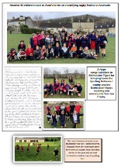  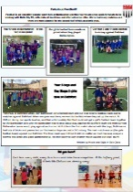  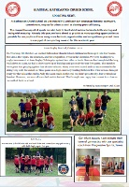 |  | Research an effective platform/ strategy for encouraging physical activity outside of school hours.
Inspire pupils to participate in physical activity for their physical and emotional well-being |  | - Fund Paralympian, Stephannie Millward, to visit Batheaston School for the day |  | £250 |  | Very inspiring visit from Stephannie linked with school vision. |  | Research other inspiration sporting speakers for next academic year.
SSCo to be employed to develop young leaders within the school, with the specific purpose of leading intra sessions, festivals and planned lunchtime activities |  | - Buy into SSCO (Brendan Rouse) to develop young sports leaders. Sport Leaders to be trained and regularly leading activity sessions during lunch time |  | See below (Key Indicator 4) |  | Sports leaders trained within curriculum time. Pupils identified as transferring their skills to the playground to increase physical activity. |  | Ensure training is earlier in the year.
Promote healthy eating |  | - Review snack policy involving school council to assess its success.  - Review range of snacks consumed.  - Hold a ‘Healthy Living’ week |  | £250 |  | Healthy Living Week increased the profile of healthy living – good parental feedback and links with catering company made. |  | Hold again next year but consider the timing within the school calendar so that all themes can be explored in further detail.

Key indicator 3: Increased confidence, knowledge and skills of all staff in teaching PE and sport |  |  |  | Percentage of total allocation:
 |  |  |  | 27%
Intent | Implementation |  | Impact
Your school focus should be clear | Make sure your actions to | Funding | Evidence of impact: what do | Sustainability and suggested
what you want the pupils to know | achieve are linked to your | allocated: | pupils now know and what | next steps:
and be able to do and about | intentions: |  | can they now do? What has
what they need to learn and to |  |  | changed?:
consolidate through practice:
Develop the skills and knowledge of teachers and of children | - Employ P.E. Specialist Teacher – James at Progressive Sports – to provide CPD and lessons to each teacher/ class for at least x1 six week block Invite local clubs to deliver taster lessons. All teachers to evaluate their CPD.  - Time table Intra-House Competitions for each class using the support from Progressive Sports.  - Junior – Infant ‘Teach Back’ to support infant class children and provide leaders opportunities | £4403  NB. Estimated sum back from after school club: £700 | Teacher feedback forms clearly demonstrated that teachers are feeling more confident and have gained new skills to teach P.E. | Discontinue with regular CPD for staff as this has been in place for the last couple of years and teacher confidence is now at a good level.
Work alongside external sport clubs and agencies to develop teacher and pupil skills and support pupil well-being | - Further develop links with Avon Rugby Club and utilise the coaching opportunities they have previously offered  - Seek further projects with: Bath RFC, Bath City FC, Team Bath Tennis, Blue Sky Tennis | £1000 | Classes have worked with: Bath Rugby, Avon Rugby, Bath RFC, Blue Sky Tennis, Baskervilles gym and Bath City FC this year. These sessions have proved very popular and have lead to children joining external clubs.  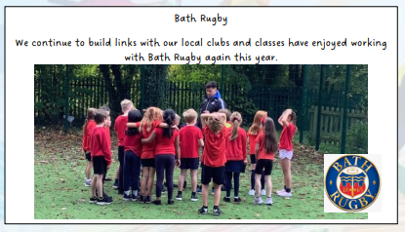 | Continue to seek further opportunities especially for dance and gym, which is harder to access club links.
Ensure lessons are well planned with well structured progression of skills and knowledge | - Subscribe to The P.E. Hub for lesson planning support | £450 | Teacher questionnaires reported that the P.E. Hub has increased their confidence and skill progression. | Subscribe to next year.
Ensure effective and innovative spending of the SSP | - P.E. Lead to attend the WES annual conference | £120 (conference cost)  £200 (supply cover for class teacher’s class) | Conference was postponed and then took place on a day we were unable to attend. | Attend Wes Sport conference.
Key indicator 4: Broader experience of a range of sports and activities offered to all pupils |  |  |  | Percentage of total allocation:
 |  |  |  | 8%
Intent | Implementation |  | Impact
Your school focus should be clear | Make sure your actions to | Funding | Evidence of impact: what do | Sustainability and suggested
what you want the pupils to know | achieve are linked to your | allocated: | pupils now know and what | next steps:
and be able to do and about | intentions: |  | can they now do? What has
what they need to learn and to |  |  | changed?:
consolidate through practice:
Offer a wide range of extra-curricular clubs | • Use pupil conferencing to assess the types of sports pupils would like to try; utilise the varied equipment and skills Progressive Sports can offer to provide different clubs | N/A | Club attendance is high especially dodgeball and football. | Use pupil voice to facilitate clubs that engage more girls in KS2.
Provide top-up swimming for all Year 6 pupils who do not meet the end of KS2 swimming objectives | •Facilitate Top-Up swimming classes and transport to children in 6 who are unable to fulfil the National Curriculum objectives. | £1000 | x13 non swimmers in Year 6 were given the opportunity to access swimming lessons. | Following feedback, move lessons to earlier in the year.
Contract Sport Safe to check gymnastic equipment | Ensure safe equipment | £250 | Equipment checked and fixed appropriately. | Continue to contract Sport Safe to check equipment.
Ensure safe equipment and maximum participation by providing a variety of sporting opportunities | Purchase new dodgeballs and footballs | £300 | Dodgeballs used to enhance club and lessons | Use pupil voice to ascertain future sport equipment investments.

Key indicator 5: Increased participation in competitive sport |  |  |  | Percentage of total allocation:
 |  |  |  | 9%
Intent | Implementation |  | Impact
Your school focus should be clear | Make sure your actions to | Funding | Evidence of impact: what do | Sustainability and suggested
what you want the pupils to know | achieve are linked to your | allocated: | pupils now know and what | next steps:
and be able to do and about | intentions: |  | can they now do? What has
what they need to learn and to |  |  | changed?:
consolidate through practice:
Ensure all pupils have the opportunity to participate in competitive sport | Buy into SSCO partnership with Bathampton Church School in order to:  - Plan festivals  - Lead festivals  - Lead ‘coached’ lessons so that all pupils are confident and safe when participating in festivals | £1400 | Every child in every class has attended a sports festival with our partner school.  Teacher, pupil and parent feedback has been very positive.  Sport Leaders have designed and lead sport festival. | Continue to buy into the hub. Discuss with Bathampton the possibility of inviting other schools.
Provide opportunities for pupils to compete in inter-school competitions | Seek opportunities for pupils who attend extra-curricular clubs to participate in inter-school matches | N/A | Pupils have been given the opportunity to participate in after school football matches, tournaments and rugby festivals. | Try to re-establish a working hub with cluster schools that sets out a timetable of after school matches in September 2023 in order to prevent the difficulties experienced this year.
All pupils to participate in annual Sports Day | - Pay for line painting  - Invest in sport awards | £300 | Memorable Sports Day. | Use council service to paint lines on Rhymes next academic year.
Total Spent: |  | £18, 353 | Total carried forward: | £1, 512

Signed off by
Head Teacher:
Date:
Subject Leader: | Jenny Enstone
Date: | July 2023
Governor:
Date:

