****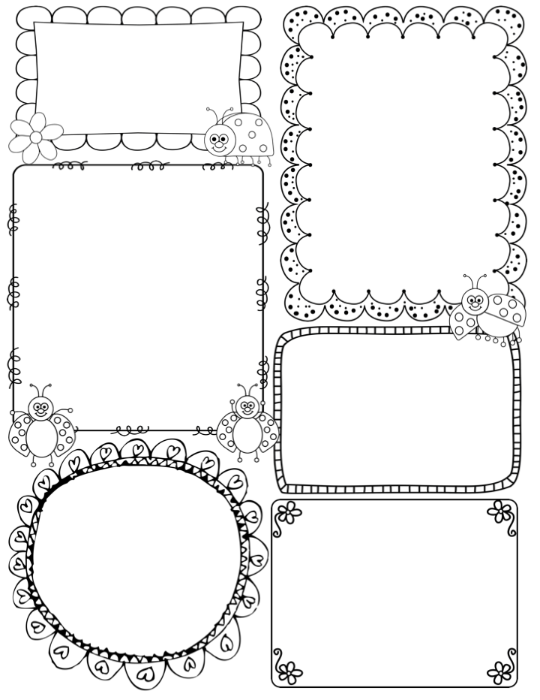

**Teacher Awards**

**Philip & Edie**

News / Information

This week it will be a fun filled but tiring one! The children are really excited to be performing for you all on Tuesday 5th, we will be having a whole school dress rehearsal today. We envisage the whole performance, including Cherry and Willow will be about an hour long. *If you feel that your child may be a little tired on Wednesday morning, you are welcome to bring them in later.*

***Reminder:***

***Tuesday 5th – Dress Rehearsal @ 9.45am***

***Evening Performance @6pm – please drop your child off at 5.30pm***

It is the Christmas lunch on Wednesday, your child is very welcome to wear their Christmas jumpers if they wish. I know the kitchen are looking forward to cooking a very festive meal!

We continue to have quite a few jumpers and clothing in the classroom – unnamed. I will put these outside the classroom for you to check – please take away.

Phonics

**Phase 2** – this week I will be carrying a 1:1 assessment with each child, you will receive a mini feedback sheet. I will also begin to hear the children read individually to check in with their colour banding.

What are we learning this week:

We finish this terms ‘Drawing Club’ with an animation! Based on last term, I have chosen Mr Benn again as the children absolutely love him. This week Mr Benn will become a Spaceman. We will continue to have fun imagining ourselves in space and on the moon! Please come into the classroom at the end of any day to take a look at the children’s work on display. I know they are very proud of what they are achieving.

In maths we are revisiting shapes again, this time looking at shapes with 4 sides. The children will explore squares and rectangles both in their play and work. We will look for shapes in our environment and create artworks based upon 4 sided shapes.

On Friday afternoon Apple class will attend the KS2 dress rehearsal, it will be lovely for them to see their special friends singing and performing.

**Apple Class Newsletter**

**Autumn 2 4th December 2023**

