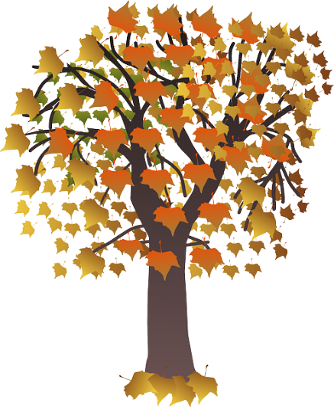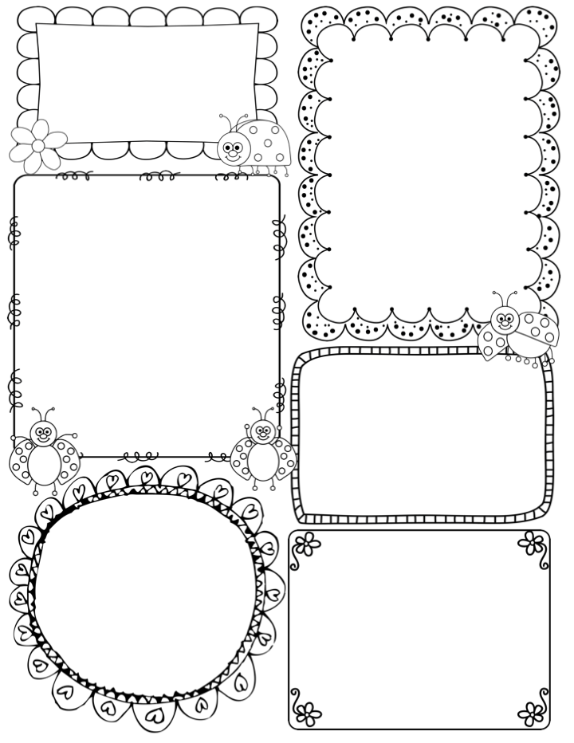

News / Information

**What a wonderful week we all had to together. Last week the children were sooooo… excited about our topic ‘Magical Journeys’ and I know that for some the subject of transport is a particular interest.**

**Although the weather was not great last week, this did not dampen the children’s spirits. Our new loose parts arrived on Wednesday and so the children were surprised to see tyres, steering wheels and walking planks outside – quickly we had trains, taxis and racing cars built ready to zoom around in our outside space!**

**We also got some time in Mike’s Meadow, where finally the children could use their wellies to tramp around in the wet leaves! Watch our Twitter feed, the children are in for a surprise this week – that will take them on a special journey around the meadow!!!**

**Finally, please check your child’s PE kit as some children were missing some key kit. We also have an increasing number of jumpers etc building up in the class (no names) I will put these outside the classroom for you to take a look.**

**Many congratulations to Elsie who won top prize for her Firework poster.**

**Teacher Awards**

**Ivy and Lexie**

Phonics

**Phase 2** – this week we continue phase 2 in our phonics programme. The class will be introduced to 4 graphemes/digraphs (v w x y)

The children will be introduced to a digraph this week (ck) they will learn the mantra ‘A digraph is two letters one sound’ Tricky words are words you cannot sound out – and, his, her, has

What are we learning this week:

In Drawing Club, we are looking at the world of pirates!! We will start the week with the story ‘The Night Pirates’ The children will be invited to draw treasure maps in the message centre, design and paint fancy pirated ships and find out what might be hiding in the treasure chest!!

In maths we are continuing to look at the composition of 1, 2, 3 with the concept of finding 1 more or less. The children are already beginning to see that 2 and 1 more will make three. Finding less or taking away can be a trickier concept to master. Therefore, we will be using lots of concrete, hands on resources to support the children with this theme.

On Friday, we will wear our science hats. We will be investigating the concept of ‘floating and sinking’. We will use the theme of boats as an initial hook, then the class will investigate the properties of different objects. Should be fun!!

**Apple Class Newsletter**

**Autumn 2 30th October 2023**

