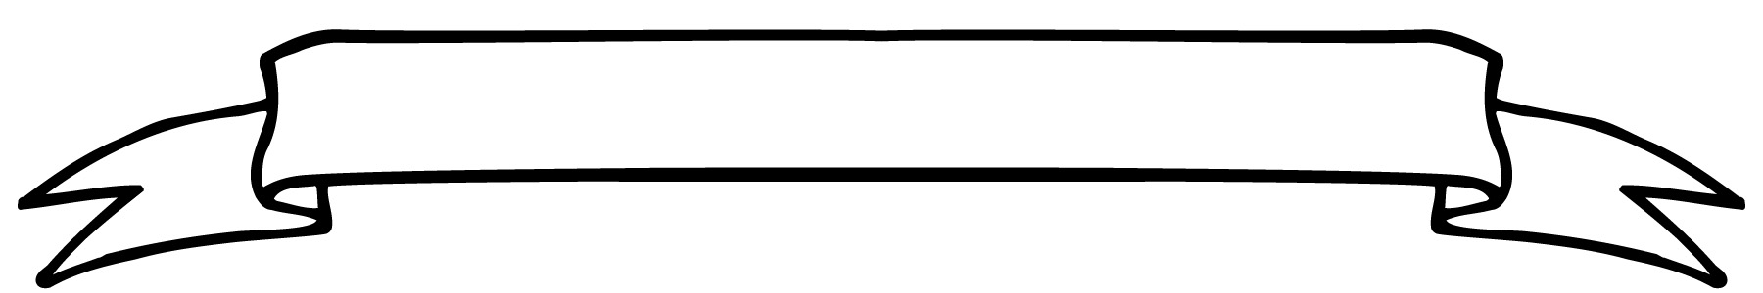**Willow Class Newsletter**

Thank you to all parents for the donations to our class hamper. I hope your children told you the reason they all had stickers from Sally. The stickers were awarded to the class who had brought in the most donations for the hampers. Willow and Apple Classes were awarded the stickers because of the generosity of their parents to our hampers.

It was lovely to see so many of you at the Winter Fair on Saturday and I hope you all had a fun time. I was very pleased to win a hamper in the raffle! If you were unable to attend but would like your children’s crafts, then please send them in with £3 and they can take them home this week.

We are rehearsing hard this week for the performance next week. The children are enjoying learning their lines and singing the songs. I am sure the show will be a huge success. I have asked Gail to send a costume letter with this newsletter as we will need some clothes to go under the main costumes which we will provide for the show.

Early last week we started our persuasive writing unit with the unexpected walk out of our classroom chairs! The children were very surprised to see the chairs gone and worked hard on persuasive letter to entice them back. They have also written letters to Apple Class advising them to eat healthy snacks. We are going to join Apple Class and read our letters to them on Tuesday. Jon is really looking forward to seeing the progress they have all made since their own time in Apple Class.

I hope you have all had a great weekend.

Best wishes

Alison

26.11.2023



**Welcome to Willow Class!**

This week’s teacher awards were awarded to:

Chloe and Ethan

**The Star of the Week was**:

Dougie

**Maths**: Emma Hopkins

**Presentation**: Elsie

**Homework**

**Reading** – from Monday we will send home a reading book on Monday and Thursday. Please read these with your child focussing on their use of sounding words they do not know. Remember to record in the reading record book when you read with your child.

**Spelling:** over the next couple of weeks we will be starting to assess where the children are for the end of the first term. This will involve a spelling fish assessment so any spelling practise would be great.

We have a community reader called Jane joining us each Monday who will be reading with some of the children.

**Dates:-**

**Tuesday pm- Natalie PPA cover.**

**Thursday – Costumes to be in school**

**Friday and Tuesday – PE**