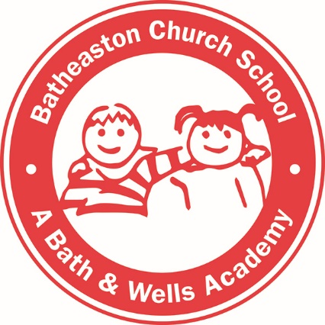

Batheaston Church School

Handwriting and Presentation Policy

Written: July 2018
Updated: September 2022
Policy Ratified by the Governing Body: _____________
Next Review Date: September 2024

At Batheaston Church School, we are constantly seeking to raise standards in all aspects of learning and teaching. Our school ethos encourages children to challenge themselves to be active, creative, independent and self–critical learners, unafraid of making mistakes. We want our children to be constantly engaged and stimulated by the richest learning opportunities available. We believe children should take pride in their learning and the presentation of pupil outcomes in books forms a core part of this.
Pupil books and folders form a record of the learning and teaching that has taken place during an academic year and as such needs to reflect a progression of personalised learning opportunities, as well as evidence of pupils making effort and taking pride in their outcomes.
We aim for our children to leave in Year 6 with the ability to write using their own style of fast, fluent, legible and joined handwriting, as well as other styles of writing for specific purposes. In addition to teaching handwriting during our regular handwriting lessons, we have high expectations that what is taught and practiced in handwriting lessons will be used in all writing activities. We believe that handwriting is integral to a child’s personal development and know that children’s engagement and self-esteem can be improved by their satisfaction and pride in good quality presentation.
This policy sets out our agreed expectation for outstanding presentation and handwriting at Batheaston Church School. This policy should be read in conjunction with the teaching & learning policy, marking and feedback policy and behaviour policy.

Aims:

- To motivate each individual to present their work in the best possible way.
- To enable children to recognise work that is presented to a high standard.
- To ensure each child knows the standard of presentation that is expected of them.
- To ensure the importance of handwriting is recognised and given appropriate time.
- To ensure the progression of handwriting is consistent across the school and that handwriting is acknowledged to be a whole body activity and emphasis is placed on correct posture and pencil grip for handwriting.
- To share this information with parents.

Children will:

- Take pride and care in the presentation of their books reflecting the high standard that is expected. This includes writing their name neatly in pencil (or pens, when ready) when working on paper.
- Use pencil for drawings or diagrams.
- When plain paper is used for writing, use a line guide to ensure presentation is neat.
- All learning must include a date and title. In KS1 date and title labels can also be used appropriately to state the learning intention and the date of every lesson.
- Cross out mistakes using a single line or use a rubber.
- Not use felt tip pens to present learning in books.
- Take time to correct and finish off work where appropriate.
- Regularly read and respond to the comments made by adults in their books using purple pens (the use of other colours – except green and pink - may also be used to support spelling learning).
- When sticking work/labels/headings in books, they are straight and cut to size.

Teachers will:
- Model presentation at appropriate times so that all pupils can achieve success. This includes page layout of work and systematic recording methods (The exception to this is in maths books – which are squared paper and pupils are encouraged to experiment with calculation methods).
- Include pupils in demonstrating good practice and celebrate effort to progress and improve.
- Follow the guidance outlined in the Batheaston Church School English Progression document
- Monitor standards closely through book scrutinies, praising children’s efforts appropriately.
- Submit one example x 6 times a year of outstanding handwriting to the English Lead for inclusion in the ‘Outstanding Handwriting Book’. This book will be displayed in the school reception.

At Foundation Stage:
Pupils are taught to take pride in their written outcomes and use a variety of methods to
develop fine motor control.
- Children experience the foundation of handwriting through multi-sensory activities.
- Children will be taught handwriting outside the phonics lesson using Phase 2 grapheme information sheets that illustrate the letter formation phrase and pronunciation phrase for each grapheme.
- Formal handwriting lessons using handwriting books will begin in Term 5.
- When necessary, The Pegs to Paper programme will be used to further support children.

When handwriting is teacher assessed as ready, the pupil will be given a lined papered book.
It is expected that by the end of EYFS all children will be able to manipulate a pencil to write their own name with a capital letter. Children will be able to include high frequency words in a simple sentence and take pride in their outcomes.

In Key Stage One:
A minimum of one discrete handwriting lesson will be taught using the Little Wandle guidance, using lined books every week. Further opportunities to practise and apply handwriting skills will be provided through E.M.T., phonic and English activities.

In Year 2, when teacher assessed as ready, pupils will be taught to join digraphs, trigraphs and full words to support spelling.
Pupils will be regularly praised for handwriting by being awarded handwriting specific stickers. Pupils will then be expected to independently and consistently maintain their high standard of handwriting.

All teachers will model handwriting using handwriting lines on the IWB in discrete handwriting lessons.

Order of joins:

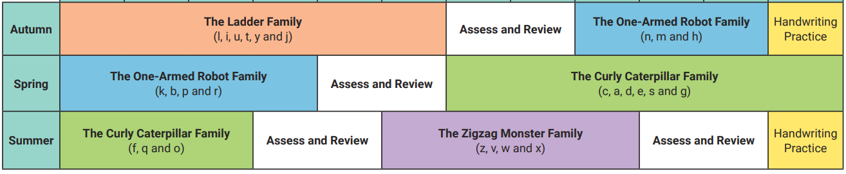

In Key Stage Two:

From Year 3 to Year 5 handwriting is taught weekly. In Year 6, it will be taught according to the needs of the children. Once the joins are secure, children are introduced to different ways of joining in order that they can develop their own preferred personal style (Y6).

By using the Twinkl Cursive handwriting scheme and handwriting and spelling resources, we ensure that our children follow the requirements and recommendations of the National Curriculum. We share the aspirations that children’s handwriting should be ‘sufficiently fluent and effortless for them to manage the general demands of the curriculum’ and that ‘problems with forming letters do not get in the way of their writing down what they want to say’.
In KS2, children who consistently demonstrate the application of the handwriting objectives in the Twinkl Cursive scheme will be given the opportunity to use a handwriting pen. Biro must not be used.

Equality of Opportunity
All of our children have equal access to handwriting lessons and to the resources available. We recognise that some children take longer to develop the necessary skills and we cater for those children by providing additional opportunities for skills development. Children who need specific fine motor or handwriting interventions are identified early and the impact of interventions is carefully monitored. Children with a physical disability are catered, and progress is monitored, according to their individual action plans.

Left-handed Children:
Left-handed children have different needs from right-handers and will be given extra support to:
- Learn the ‘tripod’ grasp and to hold the pen/pencil slightly higher up to help them to see what they are writing.
- Sit where elbows do not bump right-handers.
- Hold their writing tool away from the point so that their thumb does not get in the way.
- ‘Pull’ the pen/pencil rather than ‘push’ it across the page.

Outcomes of the presentation and handwriting policy:

- Children of all abilities are able to present their work to the highest possible standard increasing their confidence and self-esteem.
- There is consistency across the school in terms of the standard of presentation expected.
- Progression in presenting work between each class is evident and understood by all children and adults.

