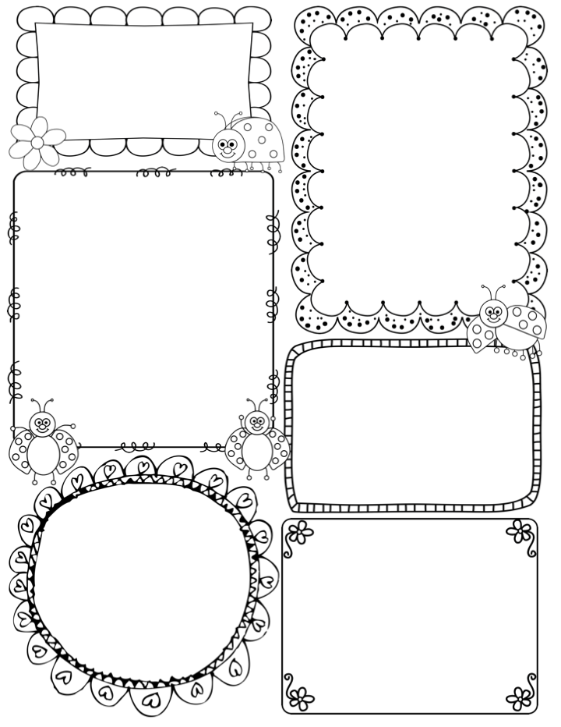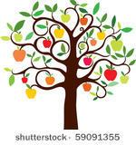

**Teacher Awards**

**Elsie and Ruben**

News / Information

Firstly, thank you to all those parents who attended the Phonics Workshop, I hope it was informative. I will carry out their first assessments on the first week back, next term. I will send out a couple of useful sheets for you to use at home. For those who could not attend, I have uploaded the PowerPoint to the Apple Class page.

Well, it is the last week of a very long term but one which has already been filled with much fun, laughter and learning. There will be a new topic next term, so I will send out a new Knowledge Organiser in due course.

We will be showing the children a video from the NSPCC ‘Pants’ campaign. We regularly show this animation and song as it supports young children’s awareness of how to keep themselves safe. If you would like to view it, please go to this link:

<https://www.nspcc.org.uk/keeping-children-safe/support-for-parents/pants-underwear-rule/>

We are immensely proud of the children as it has been a big transition in their lives, but they are happy and enthused to learn and we look forward to a very exciting and busy term 2!

*I would normally suggest that you take your child’s PE kit home to be washed but as they have only begun to get changed, I think it will be ok to leave the kits in school over half term.*

Phonics

**Phase 2** – this week we continue phase 2 in our phonics programme. The class will be introduced to 4 graphemes/sounds (h b f l)

The children will be introduced to a digraph this week (ck) they will learn the mantra ‘A digraph is two letters one sound’ Tricky words are words you cannot sound out – I is the

What are we learning this week:

In Drawing Club it is animation week, one of my childhood favourites ‘Mr Benn’. As the children are so interested in wild animals, I have opted for ‘The Zoo’. The children will be asked to draw the zoo as it’s setting and then later in the week, asked to think up a brand-new animal for the zoo.

This week we will focus on the things that make us happy, healthy and keep us safe, such as: ***healthy eating,*** ***exercise, sleep, hand washing, baths, hair care, brushing our teeth and friendships.***

On Monday we will take an autumn walk around Mike’s Meadow – set with the task to find the Apple Tree!!! We then hope to bring some cooking apples back to the classroom for our Friday activity! It will be National Apple Day on 21st October, so to celebrate the children will be baking apple muffins, using the apples picked from our own tree in Mike’s Meadow. We will conclude the week with a treat – a film and our apple muffins. Yum

**Apple Class Newsletter**

**Autumn 1 9th October 2023**

