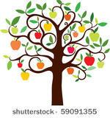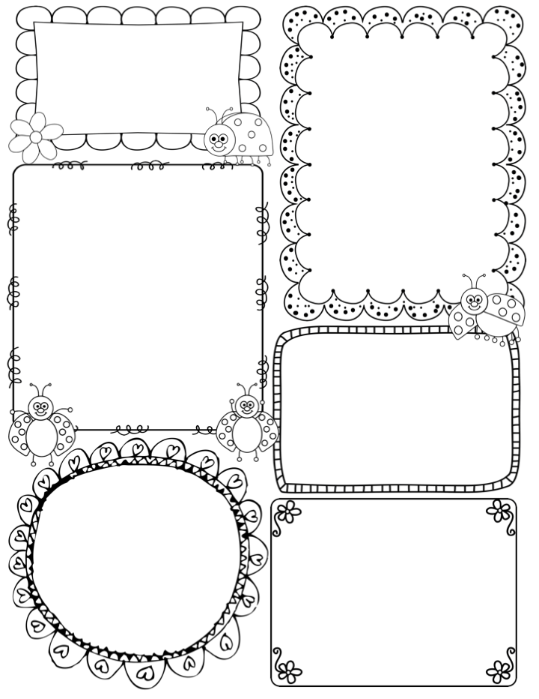

What are we learning this week:

We begin the week with Drawing Club, looking at the story ‘Chicken Licken’. On Monday afternoon we plan to go into Mike’s Meadow, following on from the theme of colour, to create an autumn colour pallet. This will support our learning about our sense of sight. I will also introduce and model the art of ‘observational drawing’ using autumn gourds as subject matter. In maths we will continue with the theme of measure; using water, sand and loose parts to investigate the capacity of different containers. During the week we will also learn about our sense of smell and hearing. We have planned ‘hands on’ activities such as making smelly potions, using herbs and spices in playdough and investigating loud and quiet sounds.

Finally, it is Hello yellow day on Friday. The children will come in dressed in yellow, to support Mental Health Day. With the class we will continue to learn about what makes us happy and healthy. I hope to take the class into Mike’s Meadow for some tree bathing!!

News / Information

What a lovely weekend, I hope you enjoyed the October sunshine!

This week will be the first of two parent meetings, **Thursday 12th October**. If you have not signed up yet, please take a look at the sign-up sheet outside the classroom. This meeting will be an opportunity for us to discuss how your child has settled in.

**Phonics Workshop for parents** -Tuesday 10th October at 9am in the classroom (Jon will take the class in the hall, so he will greet you at the lobby door as usual and the children will go straight to the hall with their bags etc. Parents can then walk straight into the classroom for 9am.

**The Book Fair** will remain open after school on Monday and Tuesday this week. On this note, I wanted to remind you that our little **Apple Class library**, is situated outside the classroom door. There are a lovely selection of picture books to share with your child. Within the book basket there is a sheet for you acknowledge the book you have taken. You are welcome to keep the book for a week or a few days.

You will notice that your child is now bringing home Pink 1A books. The words within the book reflect the phonemes/sounds we have covered so far.

Phonics

**Phase 2** – this week we continue phase 2 in our phonics programme. The class will be introduced to 4 graphemes/sounds (ck e u r)

The children will be introduced to a digraph this week (ck) they will learn the mantra ‘A digraph is two letters one sound’

**Apple Class Newsletter**

**Autumn 1 9th October 2023**

**Teacher Awards**

**Patrick and Clemmie**

