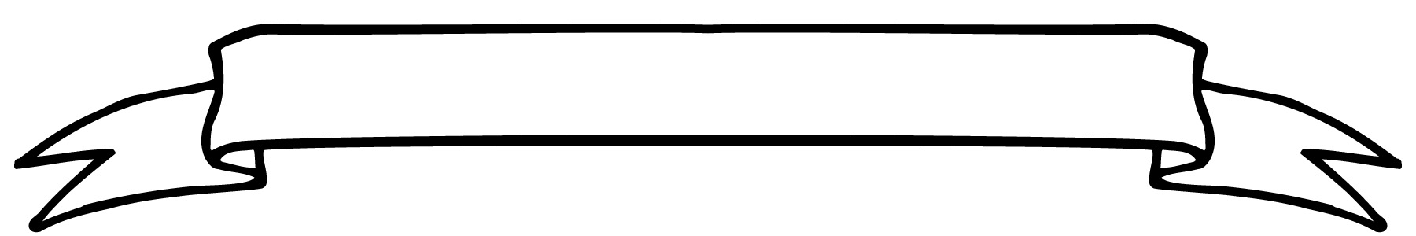**Willow Class Newsletter**

It was great to meet so many of you at the Meet the Teacher last week.

We are continuing to look at Place Value and this week we are building on our knowledge of counting in 10s to 100 and recognising all numbers to 100.

In English we are continuing our Rags to Riches pirate stories. This week the children will plan and write their own stories. On Friday 22nd the children are welcome to come to school dressed as a pirate to inspire their writing and we will be engaging in some Pirate Based activities!

In Science we are looking at fish this week. Hopefully we will be able to do a bit of pond dipping and see if there are any fish in the pond although the weather on Wednesday may be against us!

Our topic work is continuing with more investigation of the Great Fire of London. We are looking at how the people of London tried to move water from the Thames to put out the fire. We are then looking at how the lessons learnt led to the emergence of a National Fire Brigade. We are looking forward to a visit from the Fire Brigade later this term.

The children thoroughly enjoyed the session with Avonvale rugby coaches on Friday. A huge thank you to Tony and Paul.

We are looking forward to lots more fun this week.

Hope you have had a great weekend.

Alison

18.09.2023



**Welcome to Willow Class!**

This week’s teacher award is for ‘**amazing writing and spelling.’** This was awarded to:

Jinny and Polina

**The Star of the Week was**:

Ethan

**Maths**: Kitty

**Presentation**: Freya H

**Homework**

**Reading** – from Monday we will send home a decodable book on Monday and Thursday. Please read these with your child focussing on their use of sounding words they do not know. Remember to record in the reading record book when you read with your child.

We have a community reader called Jane joining us each Monday who will be reading with some of the children. Please let me know if you would like to come in and read with children as any adult support is welcomed.

**Dates:-**

**Tuesday pm- Natalie PPA cover.**

**Wednesday – outdoor science**

**Friday and Tuesday – PE**